THEORY QUESTIONS
1.
(a)

Identify the diagram below.
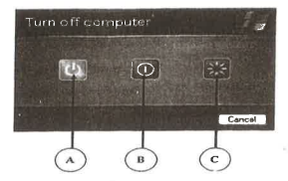
(b)

Identify the parts labelled A, B and C in (a).
(c)

Provide the names and functions of each of the following mouse pointer shapes:
(i)


(ii)


(iii)

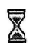
(iv)

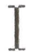
(v)

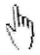
(d)

Outline the steps used to rename a folder on the desktop of a computer

2.
(a)

Explain the term word processing
(b)

Give the default extension for the following file format: Notepad.
(c)

Write the shortcut keyboard keys combination for the following commands as used in a word processing environment:
(i)

Cut
(ii)

Copy
(iii)

Paste
(iv)

Print

3.
(a)

List two examples of:
(i)

input devices;
(ii)

output devices;
(iii)

storage media;
(iv)

devices which serve both input and output purpose.
(b)

Outline two differences between storage media and storage devices.

4.
(a)

Explain the following terms:
(i)

Internet;
(ii)

Search engine.
(b)

What does the following Top Level Domains (TLDs) represent in a website address?
(i)

.com
(ii)

.edu
(iii)

.gov
(iv)

.net
(v)

.mil
(vi)

.org

5.
(a)

What is copyright?
(b)

State two reasons for copyright protection.
(c)

Give three ICT devices that can produce output on paper.
(d)

State one difference between softcopy output and hardcopy output.

